

**LEBANESE AMERICAN UNIVERSITY**

**Department of Computer Science and Mathematics**

**MTH102 – Calculus II**

**Spring 2015**

**Exam 2**

**(April 07, 2015)**

**NAME: ID:**

**Duration: 80 minutes**

Instructor: Ms. Liwa Sleiman

---------------------------------------------------------------------------------------------------------

**This exam is comprised of 8 problems.**

**Answer the questions in the space provided for each problem.**

**If more space is needed, use the back of the page.**

**Make sure to justify all your answers.**

**Graphic calculators are NOT allowed.**

---------------------------------------------------------------------------------------------------------

|  |  |  |
| --- | --- | --- |
| **Problem** | **Grade points** | |
| I | 15 % |  |
| II | 10 % |  |
| III | 07 % |  |
| IV | 15 % |  |
| V | 21 % |  |
| VI | 22 % |  |
| VII | 05 % |  |
| VIII | 05 % |  |
| **Total** | **100** |  |

1. **DO NOT evaluate**

Find the volume of the solid generated by revolving the region about the given line

1. $y=\sec{x x=-\frac{π}{4} x=\frac{π}{4}}$ about x– axis

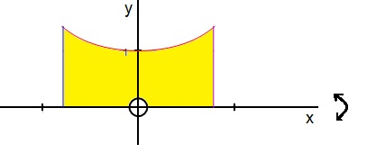

1. $y=\sqrt{\cos{x}}{ y=1 x=-\frac{π}{2} x=\frac{π}{2}}$ about x– axis

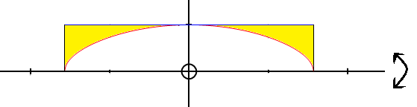

1. $x=3-y^{2} x=1$ about x– axis

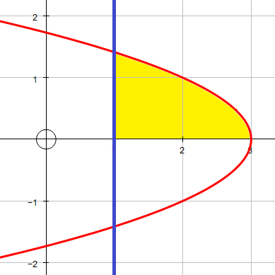

1. Find the length of the curve
$$y=\int_{0}^{x}{\sqrt{-1+\tan^{2}{t}} dt} , 0≤x≤\frac{π}{4}$$

2. Consider the functions

$f\left(x\right)= \sqrt{x-1 } , x≥0$

and $g\left(x\right)= x^{2}+1$

Show that ${g=f}^{-1}$.

1. Consider the function $f\left(x\right)=\frac{x}{ x + 1 }$
2. Find $f^{-1}\left(x\right)$.
3. Find $\left[f^{-1}\left(2\right)\right]'$ using two methods.
4. Find the derivative $\frac{dy}{dx}$

$y= e^{\sqrt{ 4-5x }}+ 3^{x^{2} tan{x}}$

$y= {\left(\ln{x^{2}}\right)}^{5}+\ln\left(xe^{\cos{x}}\sec{x}\right)$

$y= \log_{ 2} \left(\frac{ \sqrt[3]{ x^{2}-5 } }{e^{3x-1}}\right)$

1. $y=\frac{{\left( 4-x \right)}^{3} \left( e^{2x-5}\right)}{ \sin\left(x^{2}+1\right)}$ using logarithmic differentiation
2. Integrate



$\int{\left(e^{3x}+\frac{5^{\ln{x}}\ln{2}}{x}\right) dx}$

$\int{\frac{{ e}^{\left(3- \sqrt{x}\right) }}{\sqrt{x } }dx}$

$\int{\cot{x} {\left(\ln{\sin{x}}\right)}^{5} dx}$

$\int_{e}^{e^{2}}{ \frac{1}{x\ln{x}} dx}$

7. Solve the separable differential equation
$$e^{3x-5y} dy=e^{5x+7y} dx$$

8. Show that $y=e^{-x}+Ce^{-\frac{7x}{2}}$ is a solution of the differential equation $2y^{'}+7y= 5e^{-x}$